**Revit 2011 API Intro Labs**

**Lab1 – Hello World**

July, 2010 by M. Harada

**<VB.NET>**VB.NET Version**</VB.NET>**

**Objective:** In this lab, we will learn the basics of Revit API. We’ll learn how to:

* Implement an External Command or a command level add-in
* Implements an External Application or an application level add-in
* Apply attributes to your external command or application definitions
* Write an add-in manifest file to register your external command or application with Revit
* Access to a Revit model through the External Command Data

In addition, you will also have a chance to familiarize yourself with the following tools:

* RevitLookup
* Add-In Manager

**Tasks:** We’ll write two command and one application in this lab:

1. “**Hello World**” – a minimum external command that pops up a dialog with a message “Hello World”. The command will run from [Add-Ins] tab >> [External Tools] panel.
2. “**Hello World App**” – a minimum external application that pops up a dialog with a message “Hello World from App.” The dialog will pops up automatically when Revit starts up.
3. “**Command Data**” – an external command that looks at ExternalCommandData or the first argument of the IEternalCommand.Execute() method, and writes a few information from it.

Figure 1 to 3 shows the sample images from running the commands and application that you will be defining in this lab’s exercises:

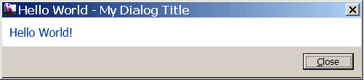

Figure 1. “Hello World” command

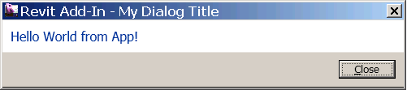

Figure 2. “Hello World App” application

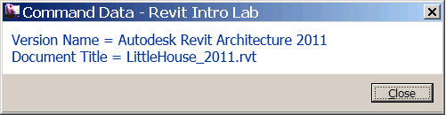

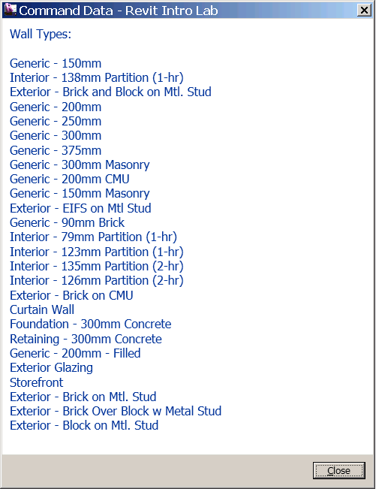

Figure 3. “Command Data” command reports some information from ExternalCommandData.

The following is the breakdown of step by step instructions in this lab:

[MH: To do after the main text is done.]

1. “Hello World”: an External Command
2. Add-in Manifest File
3. Testing Your Command
4. “Hello World” with Simplified Namespaces
5. “Hello World App”: an External Application.
6. Command Data and Revit Object Model
7. **“Hello World”: an External Command**

A Revit add-in is defined as a **Class Library** in the Microsoft Visual Studio 2008 (MSVS). If you are already familiar with defining a class library using MSVS, you can continue with the section 1.1 below.

If you are not yet familiar with MSVS or class library, “*Revit 2011 API Developer Guide.pdf*” found in the Revit SDK folder provides good walkthroughs for a Hello World in both VB.NET and C#:

* Hello World in C# - Section 2.2, pp 19
* Hello World in VB.NET - Appendix D. pp 360

If this is an instructor-lead, classroom training, your instructor will demonstrate for you.

* 1. Create a new Visual Studio project using Class Library template with the language of your choice (VB.NET or C#). Let’s name them as follows:
* Solution name: **RevitIntro**
* Project name: **RevitIntroVB**
* File name: **1_HelloWorld.vb (or .cs)**
* Command class name: **HelloWorld** (We’ll define this shortly.)

(You may choose to use any names you want here. When you do so, just remember what you are calling your own project, and substitute these names as needed while reading the instruction in this document.)

**Required References:**

Add references. We will need the following reference at least:

* System.dll
* System.Core.dll (this is for LINQ query)
* RevitAPI.dll (this is in <Revit install>\Program\ install folder)
* RevitAPIUI.dll (same as above)

**Required Namespaces:**

In addition to the default setting, add the following namespaces to your projects:

* System.Linq
* Autodesk.Revit.DB
* Autodesk.Revit.UI
* Autodesk.Revit.ApplicationServices
* Autodesk.Revit.Attributes

**Note: about VB.NET vs. C# behavior difference**   
If you are using VB.NET, you can set the above namespaces under: [Project] >> [Properties] >> [References] >> [Imported namespaces]. In fact, we recommend setting namespaces in the project properties for VB.NET project instead of using “Imports” keywords in each .vb file. Otherwise, you may encounter some error messages like the following:

>> '<class name>' is not accessible in this context because it is 'Friend'.

This error can be avoided if you use project level import settings.

C# does not have the same option of importing namespaces at project level. You will need to use “using” keyword in each .cs files to import namespaces. i.e.,

using System;

using Autodesk.Revit.DB;

using Autodesk.Revit.UI;

using Autodesk.Revit.Attributes;

* 1. Add the following code to 1_HelloWorld.vb (or .cs). This defines a minimum external command in Revit:

**<VB.NET>**

'' Hello World #1 - A minimum Revit external command.

<Autodesk.Revit.Attributes.Transaction(Autodesk.Revit.Attributes.TransactionMode.Automatic)> _

<Autodesk.Revit.Attributes.Regeneration(Autodesk.Revit.Attributes.RegenerationOption.Manual)> _

Public Class HelloWorld

Implements **IExternalCommand**

Public Function **Execute**( _

ByVal commandData As Autodesk.Revit.UI.ExternalCommandData, _

ByRef message As String, _

ByVal elements As Autodesk.Revit.DB.ElementSet) _

As Autodesk.Revit.UI.Result _

Implements Autodesk.Revit.UI.IExternalCommand.Execute

Autodesk.Revit.UI.TaskDialog.Show("My Dialog Title", "Hello World!")

Return Result.Succeeded

End Function

End Class  
**</VB.NET>**

Our command class is called “HelloWorld” and it is defined as following:

* Command class is derived from IExternalCommand.
* You will need to implement Execute() method. It takes those three arguments, and returns the Result of this command which is either “Succeeded”, “Failed” or “Cancelled.”

In this example, we simply display a message using a TaskDialog, which is a Revit style dialog.

Notice two lines at that top: Attributes for Transaction and Regeneration. These are not an optional. Without them Revit will not recognize your command.

* Transaction mode – controls the behavior of transaction, either by Automatic, Manual or ReadOnly (no transaction). If it is automatic, a transaction is created by the API framework before the beginning of the command and committed after the command in complete.
* Regeneration option – controls whether the API framework automatically regenerates or not (i.e., Automatic or Manual).

These are added in Revit 2011.

Your code is ready to build at this point. Go ahead and build the code.

**2.** **Add-in Manifest File**

Revit uses an add-in manifest file (**.addin**) to register a command and an application. Revit will read manifest files automatically at startup. There are two places where you can place manifest files on your computer: for All Users and for your user specific location.

For Windows XP:

* C:\Documents and Settings\All Users\Application Data\Autodesk\Revit\Addins\2011\
* C:\Documents and Settings\<user>\Application Data\Autodesk\Revit\Addins\2011\

For Vista/Windows 7:

* C:\ProgramData\Autodesk\Revit\Addins\2011\
* C:\Users\<user>\AppData\Roaming\Autodesk\Revit\Addins\2011\

Locate or create the folder that matches your system and the user requirement. Create a new text file, and name it “**AsdkRevitIntro.addin**”. Here is the content of the .addin file:

<?xml version="1.0" encoding="utf-8" standalone="no"?>

<RevitAddIns>

<AddIn Type="Command">

<Text>Hello World</Text>

<FullClassName>RevitIntroVB.HelloWorld</FullClassName>

<Assembly>C:\RevitAPI 2011 Training\Labs\RevitIntro\RevitIntroVB\bin\Debug\RevitIntroVB.dll</Assembly>

<AddInId>0B997216-52F3-412a-8A97-58558DC62D1E</AddInId>

</AddIn>

</RevitAddIns>

This includes information about:

* Type of your add-in, command or application
* Text that appears under [Add-Ins] tab >> [External Tools] panel
* Full class name including namespaces
* Full path to the dll or assembly module
* GUID or a unique identifier of your command.

Make necessary adjustment to match with your environment, i.e., the namespaces and the name of the class, and full path and name of the assembly. (e.g., the above example shows with VB suffix.) The section 3.4.1 Manifest Files (pp 40) of “*Revit 2011 API Developer Guide/pdf*” has a table that describes about each tag and more tag options. You can use a tool to produce a new GUID: i.e., Microsoft Visual Studio >> [Tools] >> [Create GUID].

**3. Testing Your Command**

Once you have successfully built your dll and have the .addin manifest in place, you are ready to test your command.

1. Start Revit. Start a new project. You should see [Add-Ins] tab. ([Add-Ins] is not visible when there is not add-ins registered.)
2. Under [External Tools] panel, you should see your command [Hello World]. (Figure 4.)

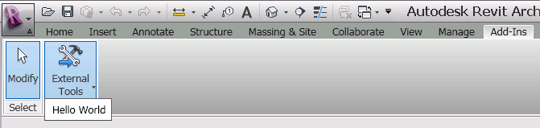

Figure 4. Your “Hello World” command should be under [External Tools] of [Add-Ins] tab.

1. Run the commend. You should see a dialog greeting “Hello World! (Figure 1).

Congratulations! You have just created your first Revit External Command.

**4. “Hello World” with Simplified Namespaces**

Let’s go back to our “Hello World” code once again. In our earlier “Hello World” code, we have used full namespaces. We have done so intentionally because we wanted to give you an idea about structure and kinds of namespaces that we are using. Once you get the basics idea, you may want to write code without spelling out full namespaces. That will certainly save your typing and make your code more readable. Here is the simplified version of “Hello World”:

**<VB.NET>**

'' Hello World #2 - simplified without full namespaces.

<Transaction(TransactionMode.Automatic)> _

<Regeneration(RegenerationOption.Manual)> _

Public Class HelloWorldSimple

Implements IExternalCommand

Public Function Execute(ByVal commandData As ExternalCommandData, _

ByRef message As String, _

ByVal elements As ElementSet) _

As Result _

Implements IExternalCommand.Execute

TaskDialog.Show("My Dialog Title", "Hello World Simple!")

Return Result.Succeeded

End Function

End Class

**</VB.NET>**

Make sure that you have imported necessary namespaces to make this work. (And if you are writing in VB.NET, make sure you import namespaces in the project property.)

You can try simplifying the code that you wrote earlier and try building it again.

**5. “Hello World App”: an External Application**

Now that we learned how to write a minimum External Command and how to register it with Revit, let’s take a look at another type of Revit Add-Ins, External Application. You can use an External Application when you want to add a functionality that needs to be executed at application level, such as when Revit starts up or when shutting down. For example, if you want to add your own Ribbon panel to the Add-Ins tab, you will call a function to add a Ribbon panel when Revit starts.

4.1 Add code for “Hello World App” External Application

The following is the minimum code for an External Application:

**<VB.NET>**

'' Hello World #3 - minimum external application

<Transaction(TransactionMode.Automatic)> _

<Regeneration(RegenerationOption.Manual)> _

Public Class HelloWorldApp

Implements **IExternalApplication**

'' OnShutdown() - called when Revit ends.

Public Function **OnShutdown**(ByVal application As Autodesk.Revit.UI.UIControlledApplication) _

As Autodesk.Revit.UI.Result _

Implements Autodesk.Revit.UI.IExternalApplication.OnShutdown

Return Result.Succeeded

End Function

'' OnStartup() - called when Revit starts.

Public Function **OnStartup**(ByVal application As Autodesk.Revit.UI.UIControlledApplication) _

As Autodesk.Revit.UI.Result _

Implements Autodesk.Revit.UI.IExternalApplication.OnStartup

TaskDialog.Show("My Dialog Title", "Hello World from App!")

Return Result.Succeeded

End Function

End Class

**</VB.NET>**

Notice that this time we are deriving a class from **IExternalApplication**. There are two functions that you can override:

* **OnStartup**() – is called when Revit starts up
* **OnShutdown**() – is called when Revit shuts down

For this exercise, we simply display a dialog with “Hello World from App!” message to the user when the Revit starts up.

You can add the code to your current document (1_HelloWorld.vb or .cs). Build your project. Make sure your code come out clean without any build errors.

[MH: no need to add Transaction mode explicitly for external application? Although samples in the SDK seem to have it all the time.]

4.2 Add Add-in Manifest File for an External Application

Here is an add-in manifest for an external application:

<AddIn Type="**Application**">

<**Name**>Hello World App</Name>

<FullClassName>RevitIntroVB.HelloWorldApp</FullClassName>

<Assembly>D:\RevitAPI 2011\Training\Labs\Revit Intro Labs\RevitIntro\RevitIntroVB\bin\Debug\RevitIntroVB.dll</Assembly>

<AddInId>08E8EFB1-FCC1-4b99-AD14-93523EE229AA</AddInId>

</AddIn>

Notice that the add-in type is “Application”, and use “Name” instead of “Text”. Other than that, tags are the same as External Command. You add this to the existing AsdkRevitInto.addin file after your previous definition of <Addin></AddIn>, which now look like the following. You will need to adjust it to fit your environment, of course:

<?xml version="1.0" encoding="utf-8" standalone="no"?>

<RevitAddIns>

<AddIn Type="Command">

<Text>Hello World</Text>

<FullClassName>RevitIntroVB.HelloWorld</FullClassName>

<Assembly>C:\RevitAPI 2011 Training\Labs\RevitIntro\RevitIntroVB\bin\Debug\RevitIntroVB.dll</Assembly>

<AddInId>0B997216-52F3-412a-8A97-58558DC62D1E</AddInId>

</AddIn>

**<AddIn Type="Application">**

**<Name>Hello World App</Name>**

**<FullClassName>RevitIntroVB.HelloWorldApp</FullClassName>**

**<Assembly>D:\RevitAPI 2011\Training\Labs\Revit Intro Labs\RevitIntro\RevitIntroVB\bin\Debug\RevitIntroVB.dll</Assembly>**

**<AddInId>08E8EFB1-FCC1-4b99-AD14-93523EE229AA</AddInId>**

**</AddIn>**

</RevitAddIns>

Alternatively, you can create a separate .addin file if you prefer.

4.3 Test Your Application.

You are ready to test your application. Simply start Revit. You should see a message “Hello World from App” automatically popping up when Revit starts (figure 5)



Figure 5. A dialog message from your external application at Revit startup.

**6. Command Data and Revit Object Model**

Now that we have understand how to define an external command and application in Revit, let’s go back to our external command and look at the command arguments for Execute() method more closely. You see three arguments passed through Execute():

1. commandData (ExternalCommandData) – the top most object and entry point to access Revit model (Input)
2. message (String) – a message to the user when the command fails (Output)
3. elements (ElementSet) – a list of elements you want to highlight when a command fails (Output)

6.1 Examine commandData in the Debugger

The most important object of all is the commandData. Accessing to the Revit model starts here. To see what’s in there, place a breakpoint somewhere in the “Hello World”, for example, at the line of TaskDialog.Show(), and run the command again. When you hit the breakpoint, take a look at commandData. You can drill down from the commandData and see what kind of information is accessible from there. For example, by “drilling down” the hierarchy,

commandData >> Application >> Application >> VersionXxx

you can obtain the version name, version number and built number of Revit that you are currently running. Figure 5 and 6 below show sample images from a drill down in a code and in the Locals view.

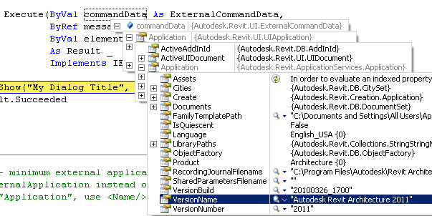

Figure 6. Examining commandData in the code

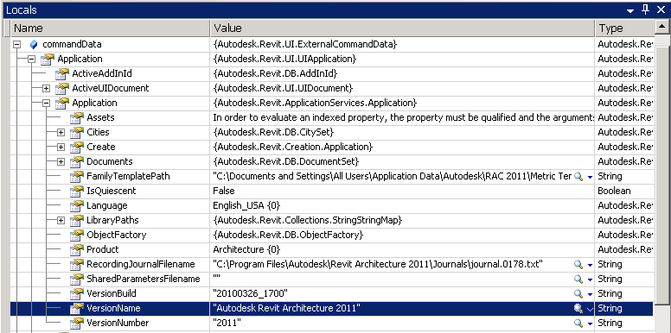

Figure 7. Examining commandData in Locals view

Let’s define a new command to show a few data from the commandData.

6.2 Define a new external command class.

Let’s name your new external command class as “CommandData”, for example.

* Command class name: **CommandData**

Using the debugger, explore what kind of information you can obtain from the commandData. Write a code to print out some information found there. (Note: At this point, we haven’t looked at the detail of objects that are specific to Revit API. Please keep it simple. Try choosing data that is easy to printout, such as ones that represented as a String data.)

The following is example of the code where we print out version information and names of wall types in the Revit file:

**<VB.NET>**

'' Command Arguments and Revit Object Model

<Transaction(TransactionMode.Automatic)> _

<Regeneration(RegenerationOption.Manual)> _

Public Class CommandData

Implements IExternalCommand

Public Function Execute(ByVal commandData As ExternalCommandData, _

ByRef message As String, _

ByVal elements As ElementSet) _

As Result _

Implements IExternalCommand.Execute

'' print out a few information that you can get from commandData

Dim versionName As String = _

commandData.Application.Application.VersionName

Dim documentTitle As String = _

commandData.Application.ActiveUIDocument.Document.Title

TaskDialog.Show("Revit Intro Lab", "Version Name = " + versionName _

+ vbCr + "Document Title = " + documentTitle)

'' print out wall types available in the current rvt project

Dim wallTypes As WallTypeSet = _

commandData.Application.ActiveUIDocument.Document.WallTypes

Dim s As String = ""

For Each wType As WallType In wallTypes

s = s + wType.Name + vbCr

Next

'' show the result.

TaskDialog.Show("Revit Intro Lab", "Wall Types: " + vbCr + vbCr + s)

Return Result.Succeeded

End FunctionEnd Class

**</VB.NET>**

Build the code. Make sure it was compiled without any error.

6.3 Add an add-in manifest file

You must know how add-in manifest file works by now (cf. section 2. “Add-In Manifest File” above.) Here is an example:

<AddIn Type="Command">

<Text>Command Data</Text>

<FullClassName>RevitIntroVB.CommandData</FullClassName>

<Assembly>D:\RevitAPI 2011\Training\Labs\Revit Intro Labs\RevitIntro\RevitIntroVB\bin\Debug\RevitIntroVB.dll</Assembly>

<AddInId>AA90426A-E8AA-45b4-84AF-861E865871AE</AddInId>

</AddIn>

6.4 Run and test the command

If everything goes well, you should see dialogs showing some information obtained from the commanddata when you run “Command Data”. Figure 7 below shows images from the sample execution when running the command using Revit project with DefaultMetric template.





Figure 8. “Command Data” command reports some information from ExternalCommandData.

**6. Summary**

Congratulations!! You have completed your first lab.

In this lab, you have learned the basics of Revit API. We have learned how to:

* Implement an External Command or a command level add-in
* Implements an External Application or an application level add-in
* Apply attributes to your external command or application definitions
* Write an add-in manifest file to register your external command or application with Revit
* Access to a Revit model through the External Command Data

In the next lab, we will take a look at each Revit element more closely and learn how Revit element is represented in the product.

**Tools**

Before we go to the next lab, we want to point to a few tools that will be useful when learning and debugging Revit API.

* **RevitLookup** – this is a tool that allows you to “snoop” into the Revit database structure. You can find it in the SDK folder. We’ll be using it through out this lab. This is the “must have” for any Revit API programmers.
* **Add-In Manager** – this tools allows you to load and unload your dll while running Revit. You can find this in the SDK folder.
* **SDKSamples2011.sln** – this solution file, found in the /Samples/ folder, is provided to make it easier to build all the sample projects at once. There are more than 100 samples in the Revit SDK now. It will be a tadious task if you want to all the build samples. This becomes handy when you want to build and explore many samples. In conjunction with SDKSamples2011.sln, **RevitAPIDllsPathUpdater.exe** is provided to update the location of references in each MSVS projects in case your installation of Revit is different from the default location or if you are using different verticals.
* **RvtSamples** – this is one of samples found in the /Samples/ folder. [MH: to finish]

If this is an instructer-lead classroom training, your instructer may demonstrate them. Please take a look at them and have at least RevitLookup installed for the subsequent labs.

Autodesk Developer Network